**DAILY ONLINE ACTIVITIES SUMMARY**

|  |  |  |  |  |  |  |  |
| --- | --- | --- | --- | --- | --- | --- | --- |
| **Date:** | **06-06-2020** | | | | **Name:** | **B.A.SOHANKUMAR** | |
| **Sem & Sec** | **4TH SEM A** | | | | **USN:** | **4AL18CS013** | |
| **Online Test Summary** | | | | | | | |
| **Subject** | | **DATA COMMUNICATION** | | | | | |
| **Max. Marks** | | **30** | | **Score** | | **25** | |
| **Certification Course Summary** | | | | | | | |
| **Course** | **TIME SERIES ANALYSIS IN R** | | | | | | |
| **Certificate Provider** | | | **GREAT LEARNING ACADEMY** | **Duration** | | | **5 HOURS** |
| **Coding Challenges** | | | | | | | |
| **Problem Statement:1:Write a java program to find second highest number in an array.**  **Problem Statement:2:Write a program in C to rotate an array by N positions.** | | | | | | | |
| **Status: EXECUTED** | | | | | | | |
| **Uploaded the report in Github** | | | | **YES** | | | |
| **If yes Repository name** | | | | **LOCKDOWN CODING** | | | |
| **Uploaded the report in slack** | | | | **YES** | | | |

**ONLINE TEST DETAILS:**

Today online test was on 5th module of DATA COMMUNICATION (18CS46).The duration of the test was 40 minutes from 9.30am to 10.15am.30 multiple choice questions.Score I received is 25/30.



**CERTIFICATION COURSE DETAILS:**

Course:TIME SERIES ANALYSIS IN R

Today I have completed next 6 topics of this course that are Case study on Decomposition method part 2,Case study on Decomposition method part 3,Model Forecast theory,Model Forecast hands-on,Hands-on exercise on Time Series Forecasting,Hands-on exercise using Exponential smoothing function and completed assessment quiz.

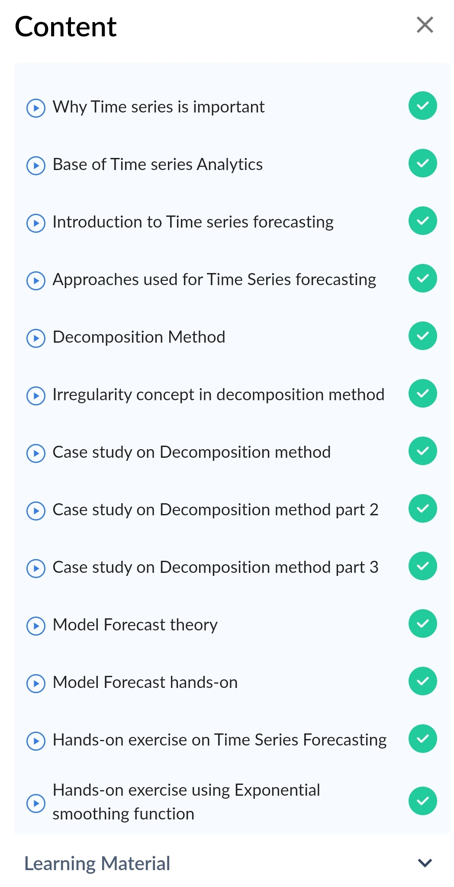

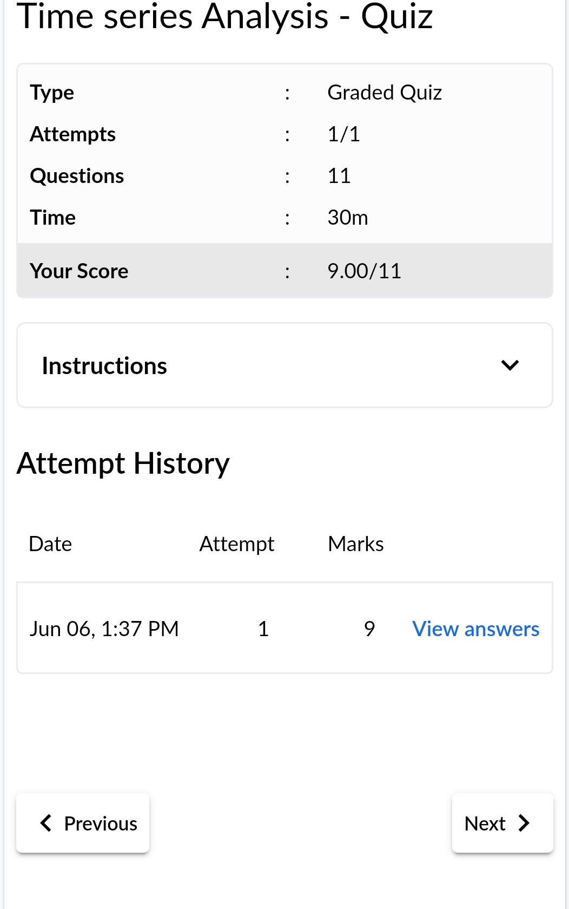



The above certificate is awarded for completion of this course.

**CODING CHALLENGES:**

1.Write a Java Program to find the second-highest number in an array.

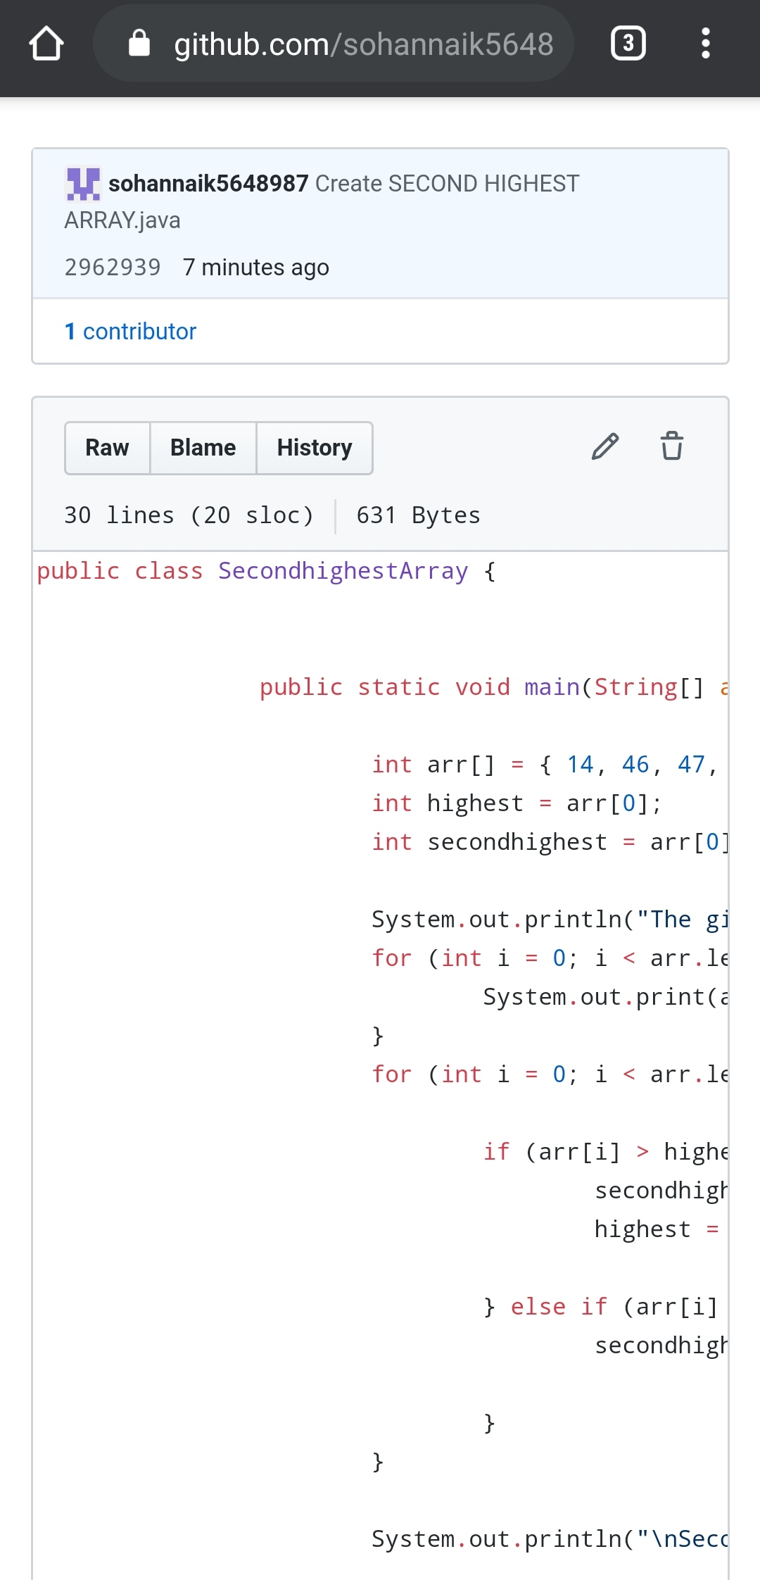

2.Write a program in C to rotate an array by N positions.

Expected Output :The given array is : 0 3 6 9 12 14 18 20 22 25 27

Enter the Position N from where you want to rotate: 4

From 4th position the values of the array are : 12 14 18 20 22 25 27

Before 4th position the values of the array are : 0 3 6 9

After rotating from 4th position the array is:12 14 18 20 22 25 27 0 3 6 9

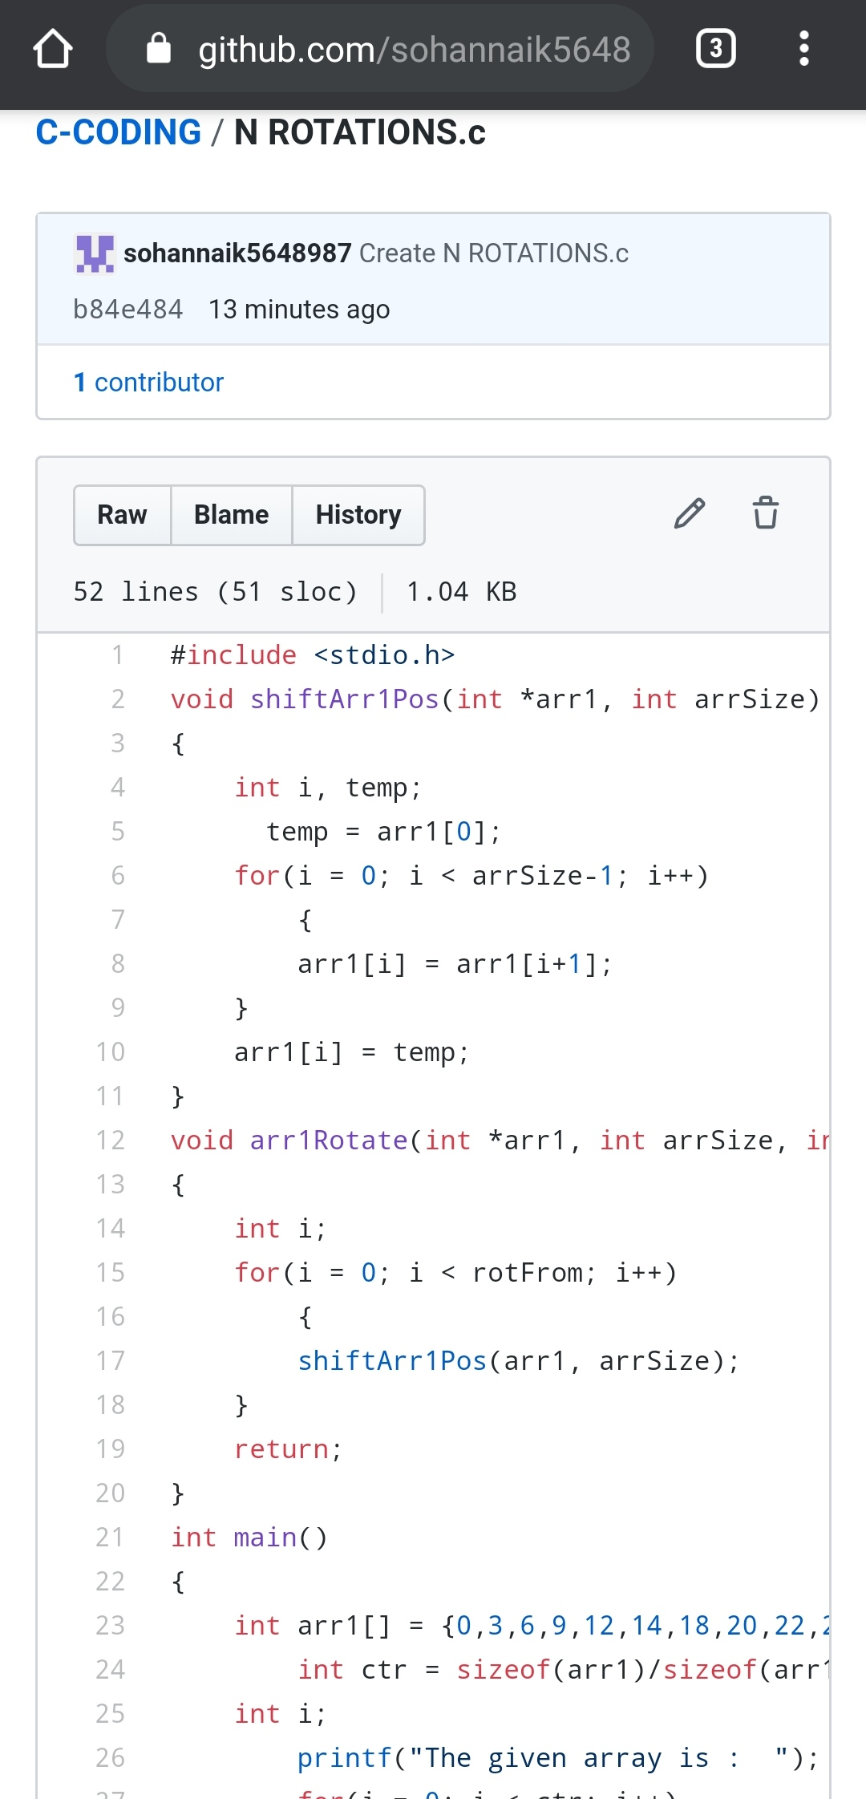

REPOSITORY LINK:https://github.com/sohannaik5648987/C-CODING

https://github.com/sohannaik5648987/JAVA-CODING